Deploying maven build “war” file to tomcat server using SSH-AGENT

Once maven build is successful we need to copy the war file from jenkins server to tomcat server into tomcat’s webapps directory over ssh.

STEP-1: install SSH-AGENT plugin in jenkins

Manage jenkins 🡺 Manage Plugins 🡺 Available plugins 🡺 Search for “ssh”.

Click on “Install without restart”

Once installation success restarts the jenkins server.

STEP-2: Once restart done go to jenkins and add the ssh credentials to connect with tomcat server instance from jenkins server instance.

Manage jenkins 🡺 Manage Credentials

Click on Jenkins

Click on “Global credentials”

Click on Add Credentials

Enter kind

Enter scope

Enter ID, Description

Enter the EC2 instance default username

1. ubuntu # for ubuntu os
2. ec2-user # for redhat and amazon linux os

click on “Enter directly” on private key

Now, open you aws pem key file and copy the key inside it

Copy this key and paste it in the “enter directly” section

Click on “Create”.

Now, our credentials for connecting jenkins server with tomcat instance are added successfully.

STEP-3: Now, go to jenkins pipeline job and add the new stage to copy the build file from jenkins to tomcat server over ssh agent.

Go to Pipeline section

Add a new stage to copy the build file from jenkins to tomcat server.

Now, generate the step code using “Pipeline Syntax”.

This is the code generated, copy this code and paste it in the step.

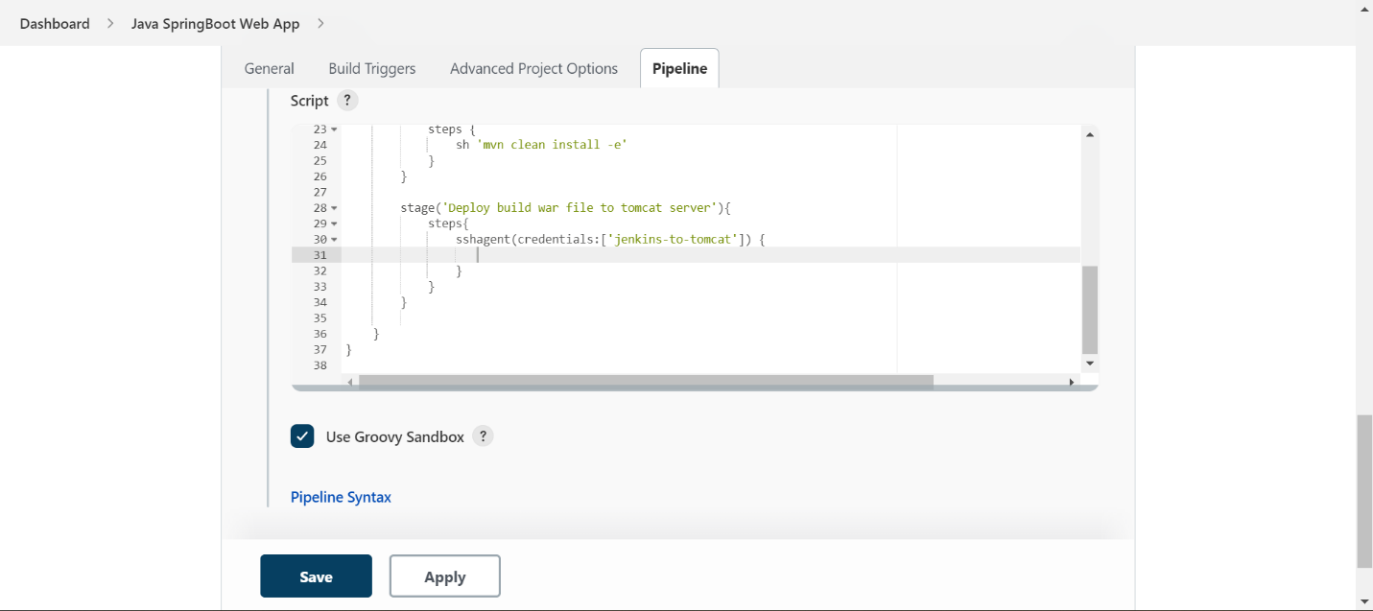

Now, write the scp (secure copy) command in the “sshagent” step.

**scp syntax:**

scp <source path> remote-user@ip-address:<destination path>

* sh 'scp -o StrictHostKeyChecking=no /home/ec2-user/jenkin_workspace/workspace/Java-SpringBoot-WebApp/target/ROOT.war ubuntu@54.90.96.16:/opt/apache-tomcat-9.0.65/webapps/myapp.war'

If we execute this command, it will ask the prompt like “would you like to allow login or not”, so our stage will halted of failed until we provide yes/no.

We have to bypass this check.

Add this parameter in the scp command.

-o StrictHostKeyChecking=no

here, -o 🡺 for authentication

* sh 'scp -o StrictHostKeyChecking=no /home/ec2-user/jenkin_workspace/workspace/Java-SpringBoot-WebApp/target/ROOT.war ubuntu@54.90.96.16:/opt/apache-tomcat-9.0.65/webapps/myapp.war'

copy the scp command and paste in the step.

Apply and save the changes.

Now, lets build the pipeline

Build 35 started

Our build got failed in deploy stage, let’s check the build logs.

Click on build number 35.

Go to “Console Output”

It’s unable to find the “Destination” path.

**Cause:**

We are logging to the tomcat server as “ubuntu” user, But our tomcat installation directory path files are owned by “root” user.

**Resolution:**

Change the ownership of tomcat installation directory path from root user to ubuntu user.

* sudo chown -R ubuntu:ubuntu /opt/apache-tomcat-9.0.65

this will give the access to all the files in tomcat cat installation directory to ubuntu user.

Before “chown” command

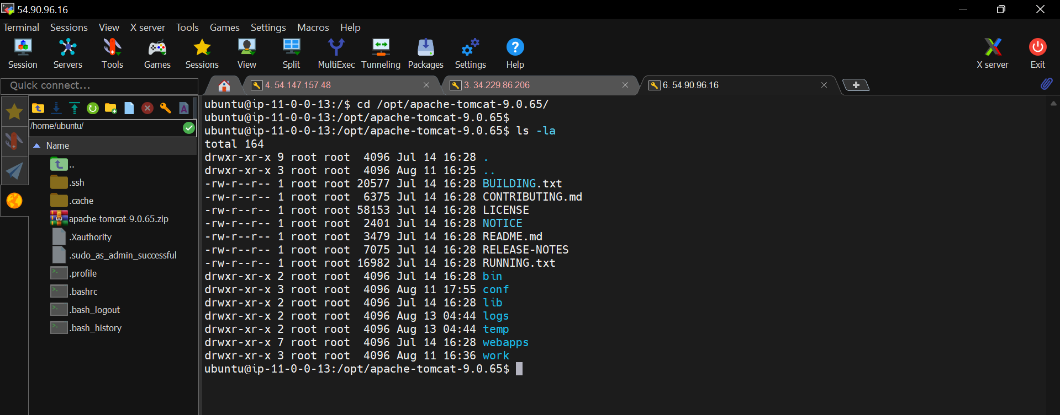

After “chown” command

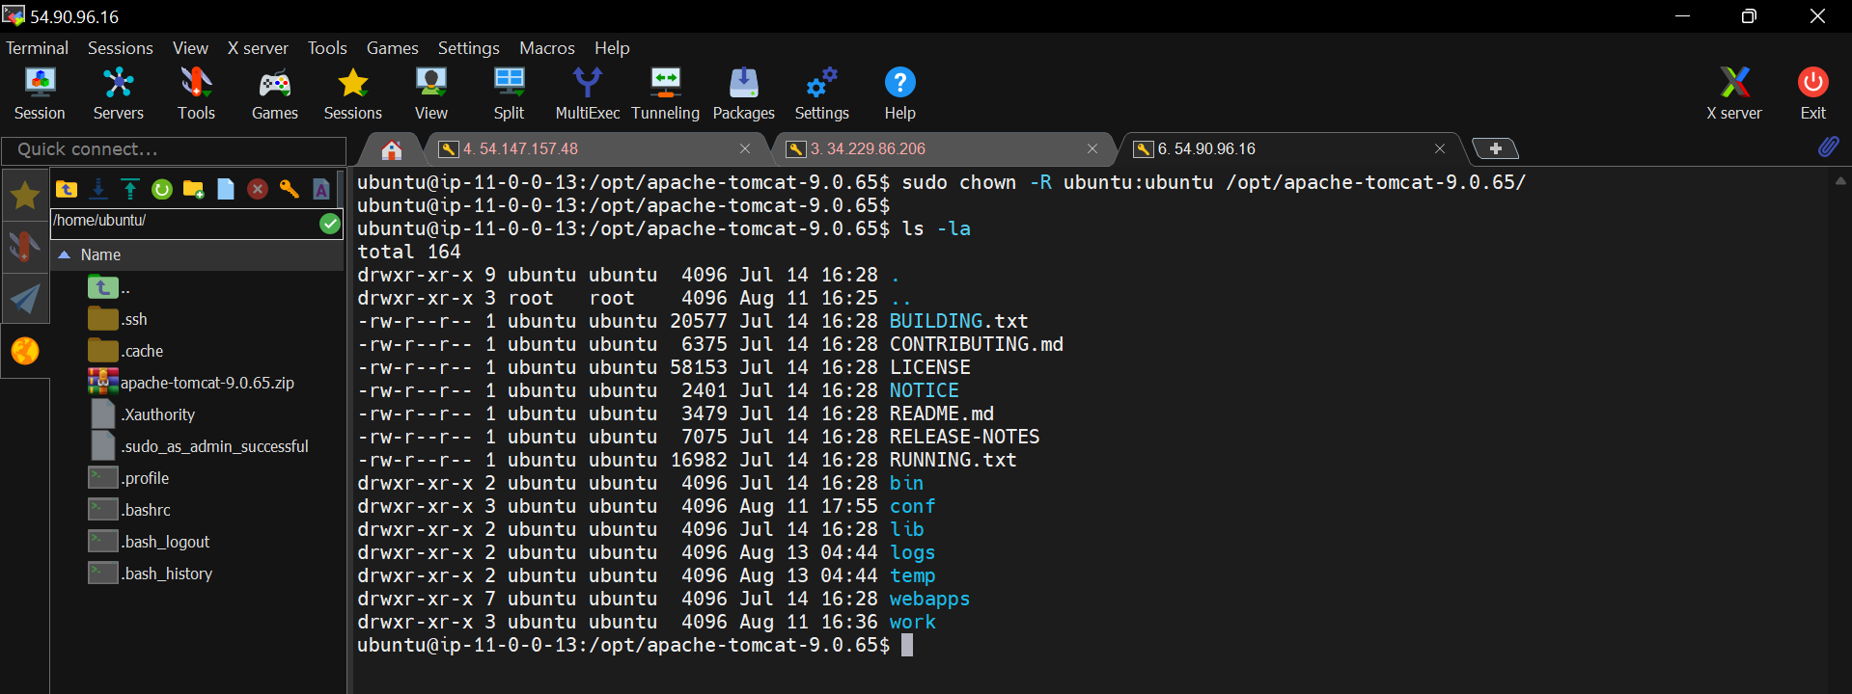

Now, run the build

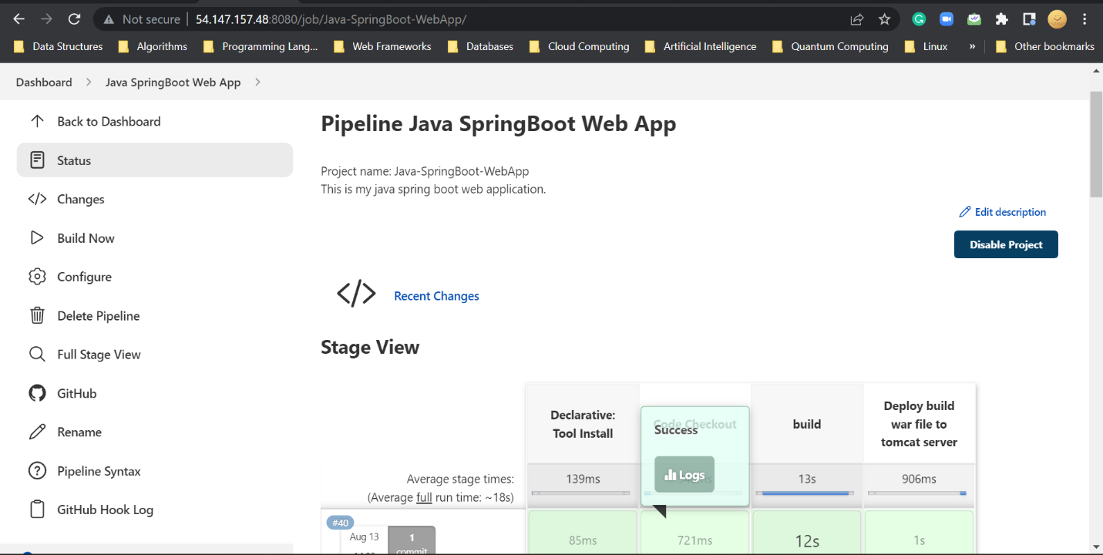

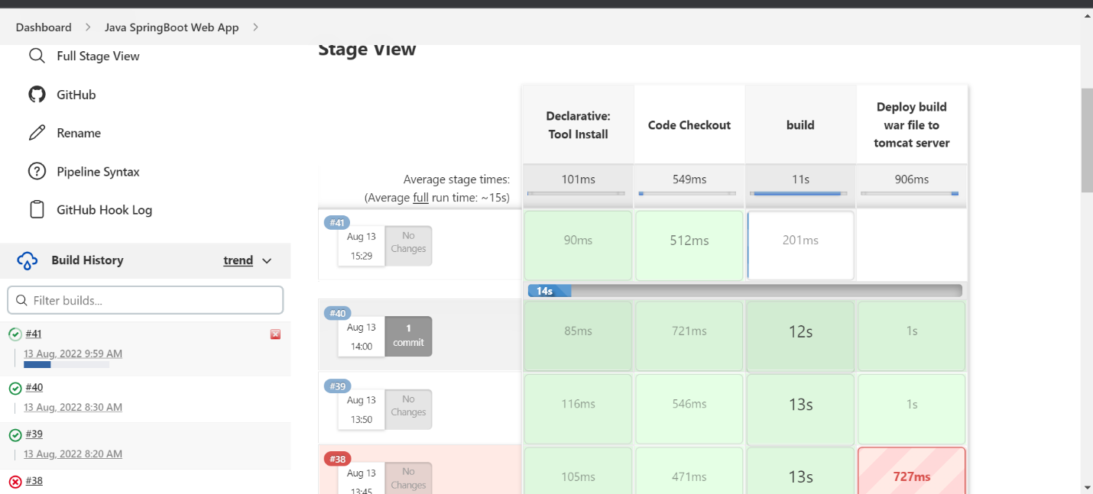

New build 41 is started.

Build got success and deployed to tomcat server successfully.

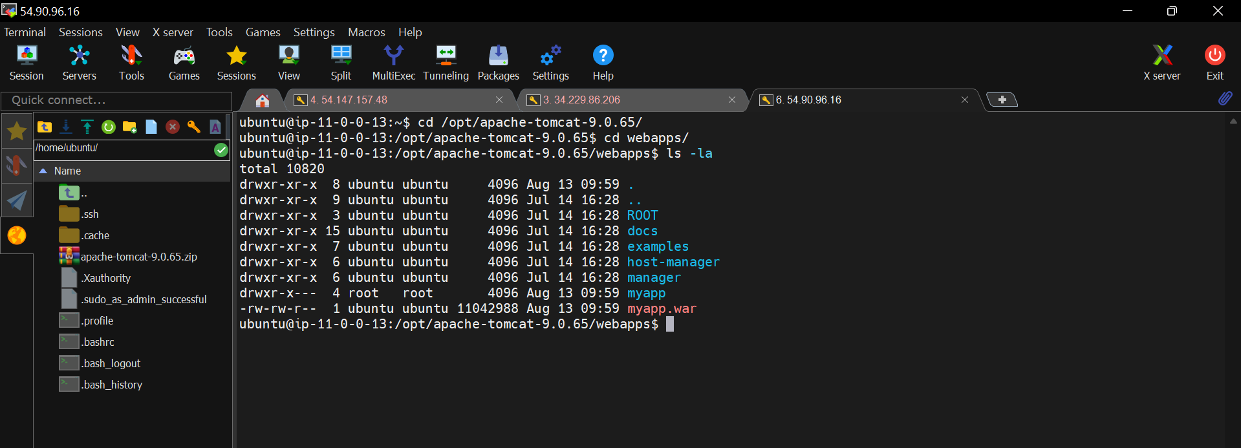

We can see that our war file successfully copied to tomcat server.

Now, go to tomcat server and enter the app name after the port number.

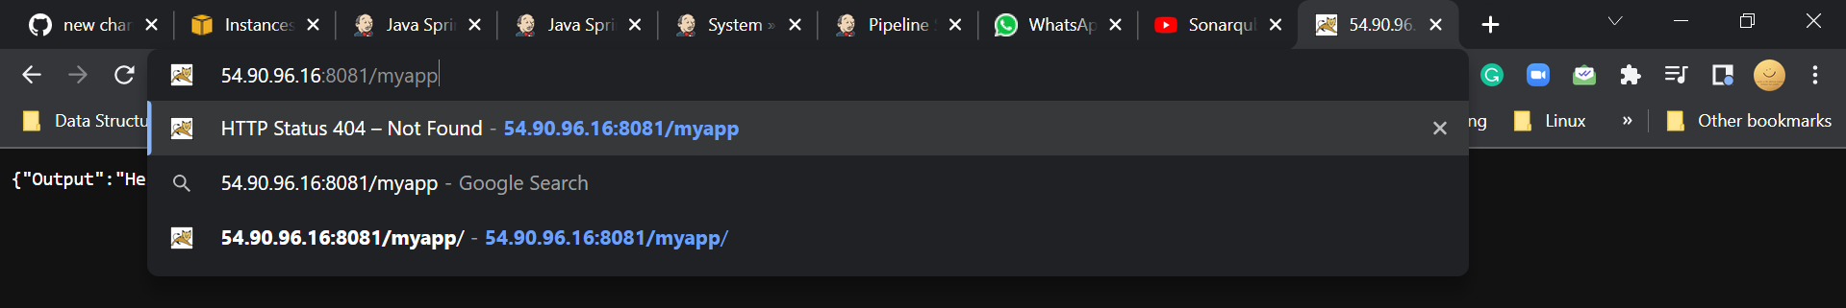

We can see our app output here.